***2016 UChicago BSD Q-Bio Boot Camp***

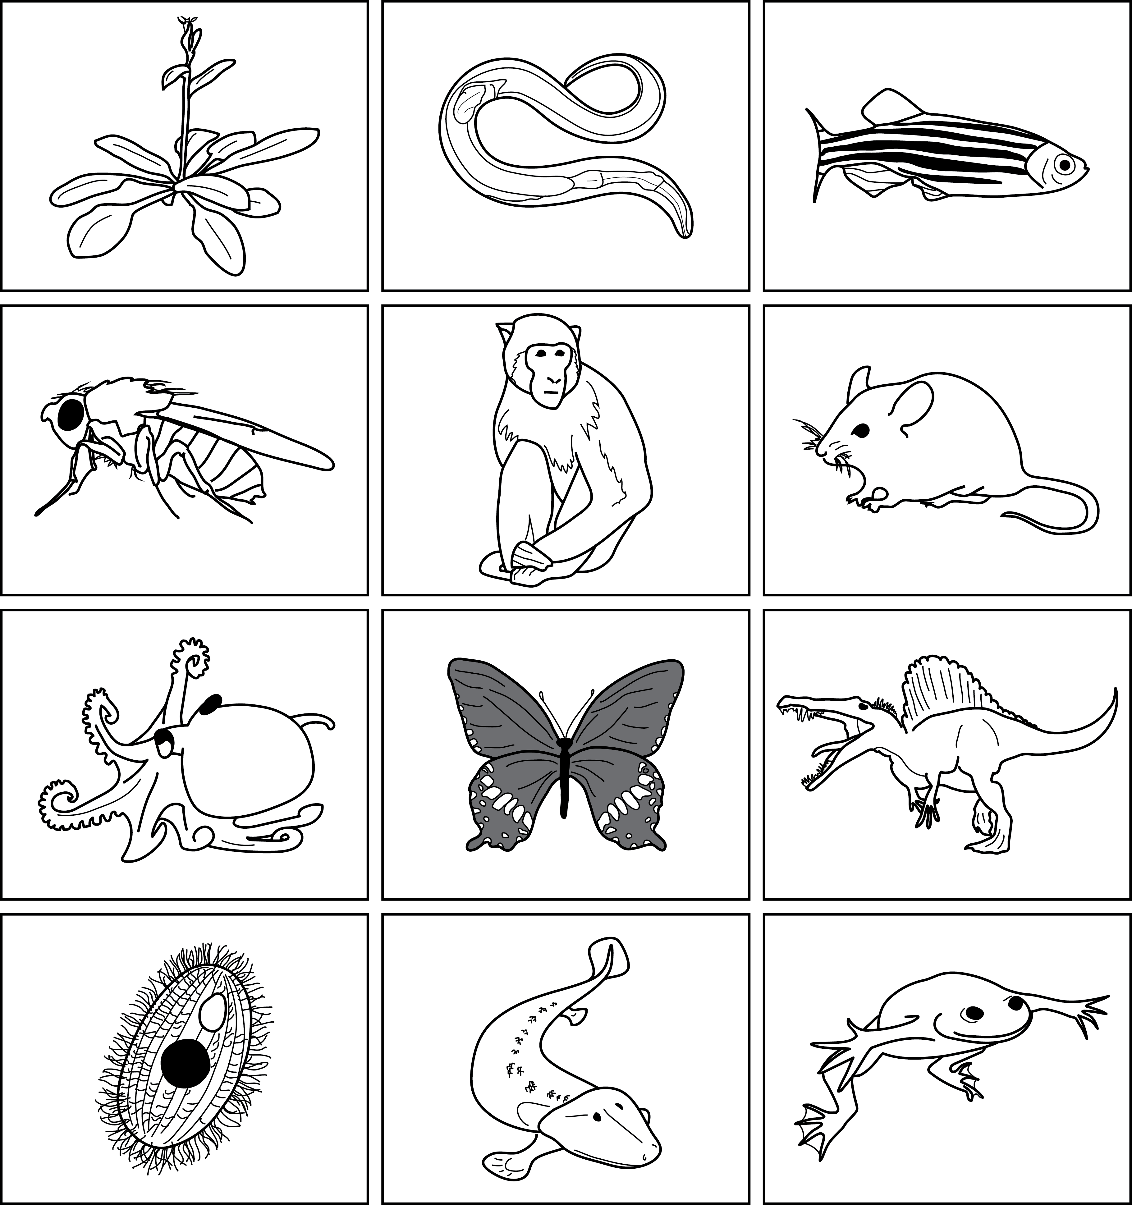

***Marine Biological Laboratory, Woods Hole, MA***